**SCHOLAR ULTIMATE MATRIX(SUM)**

**A**

**MINOR PROJECT REPORT**

**Submitted in partial fulfillment for the award of the Degree of**

**MASTER OF COMPUTER APPLICATIONS**



**Submitted by**

**SATYENDRA KUMAR NAMDEO**

(0101CA231056) **ABHISHEK SAHARE**

(0101CA231002)

**SHRADDHA PATERIYA**

(0101CA231064)

MCA III semester

**Under the Guidance of**

**Mr. Dheeresh Chandra Kushwaha**

Assistant professor

Department of computer applications UIT, RGPV, Bhopal

**SUBMITTED TO**

**Department Of Computer Applications**

**University Institute of Technology, RGPV, Bhopal (MP)**

**UNIVERSITY INSTITUTE OF TECHNOLOGY,**

**RAJIV GANDHI PROUDYOGIKI VISHWAVIDYALAYA**

**BHOPAL**

**Session: July – Dec 2024**

**DECLARATION**

We, **Satyendra Kumar Namdeo, Abhishek Sahare, Shraddha Pateriya**, students of Master of Computer Applications, University Institute of Technology, RGPV, Bhopal, hereby declare that the presented project is the outcome of my original work, authentic, correct to the best of my knowledge and carried out with ethics in mind. The results embodied in this project are not an infringement to any patented work nor have they been submitted to any University of Institute for any award or diploma.

**SUBMITTED BY**

**SATYENDRA KUMAR NAMDEO**

**ABHISHEK SAHARE**

**SHRADDHA PATERIYA**

**UNIVERSITY INSTITUTE OF TECHNOLOGY,**

**RAJIV GANDHI PROUDYOGIKI VISHWAVIDYALAYA**

**BHOPAL**



**CERTIFICATE**

This is to certify that the project work entitled **SCHOLAR ULTIMATE MATRIX (SUM**) carried out by **SATYENDRA KUMAR NAMDEO(0101CA231056.), ABHISHEK SAHARE (0101CA231002), SHRADDHA PATERIYA(0101CA231064)** students of MCA III semester, University Institute of Technology, RGPV during the year 2024-25 under my guidance and supervision is approved by me for the partial fulfillment of the requirement for the award of the degree of **MASTER OF COMPUTER APPLICATIONS.**

Guided by

**Mr. Dheeresh Chandra Kushwaha**

Assistant Professor

Department of Computer Applications UIT, RGPV, Bhopal

Approved by

**Prof. Ravindra Patel Prof. Sudhir S. Bhadauria**

Professor & Head Director

Dept. of Computer Applications UIT, RGPV, Bhopal

UIT, RGPV, Bhopal MP

**ACKNOWLEDGEMENT**

This gives us a great pleasure to express our deep sense of gratitude to our project guide **Mr. Dheeresh Chandra Kushwaha,** Assistant Professor, Department of Computer Applications for guidance, suggestion, support, help and constructive criticisms throughout the period of project work. Without his able guidance it would not have been possible to complete the project in time.

We are greatly indebted to **Dr. Ravindra Patel (Professor & Head)** and **Dr. Neelu Nihalani (Professor)**,Department of Computer Applications for their keen interest in this work and time to time guidance, encouragement and providing required facilities for completing the project work. We express our thanks to **Prof. Sudhir S. Bhadauria**, Director, University Institute of Technology, Rajiv Gandhi Proudyogiki Vishwavidyalaya**,** Bhopal for extending his support and critical comments which improved the quality of this report.

I would also like to thank the support staff of the Department of Computer Applications for their help and support.

**SATYENDRA KUMAR NAMDEO (0101CA231056)**

**ABHISHEK SAHARE (0101CA231002)**

**SHRADDHA PATERIYA (0101CA231064)**

**Table of Contents**

FRONT PAGE …I

DECLARATION …II

CERTIFICATE …III

ACKNOWLEDGEMENT …IV

TABLE OF CONTENTS …V

LIST OF FIGURES ...VII

LIST OF TABLES …VIII

ABSTRACT …IX

1. **Introduction 02-07**
   1. Introduction to Project
   2. Motivation
   3. Problem Statement
   4. Scope of the Project
   5. Objectives
2. **Requirement Analysis 08-16**

2.1 Objectives (Primary Objectives, Secondary Objectives)

2.2 Functional Requirements

2.3 Non-Functional Requirements

2.4 SDLC Model Used

**3. System Requirement Specifications 17-21**

3.1 Specific Requirements

3.1.1 Client Session Access

3.1.2 Shared file System

3.2 Hardware Requirements

3.3 Software Requirements

3.4 Interfaces

3.4.1 ASP.NET Visual Studio 2010

**4. Analysis and Design 22-33**

4.1 System Design

4.1.1 Diagrams

4.1.2 Dataset Considerations

4.1.3 Data Import

4.1.4 Preprocessing Dataset

4.1.5 Data Manipulation

4.1.6 Data Visualization

4.2 Analysis

4.2.1 Functional Analysis

4.2.2 Data Analysis

4.2.3 Performance Analysis

4.2.4 Usability Analysis

4.2.5 Security Analysis

**5. Implementation 34-50**

5.1 Software Tools

5.1.1 ASP.NET: For Dynamic Web Development

5.1.2 C#: Backend Logic

5.1.3 SQL Server: Database Management

5.1.4 SMTP: Email Notifications

5.2 Coding Standard

5.2.1 Adherence to Modular Programming Principles

5.2.2 Consistent Naming Conventions

**6. Testing 51-53**

6.1 Unit Testing: Individual Modules

6.2 Integration Testing

6.3 System Testing

6.4 Performance Testing

6.5 Result and Discussion

6.6 Final Look of the UI and Database

**7. Conclusion 54**

**8. Future Enhancement 55-56**

**References**

**List of Figures**

|  |  |  |
| --- | --- | --- |
| **Figure No.** | **Title** | **Page No.** |
| **Fig. 4.1.1** | **Class Diagram** |  |
| **Fig. 4.1.2** | **Use Case Diagram** |  |
| **Fig. 4.1.3** | **Flowchart** |  |

**List of Tables**

|  |  |  |
| --- | --- | --- |
| **Table No.** | **Title** | **Page No.** |
|  |  |  |
|  |  |  |
|  |  |  |
|  |  |  |

**ABSTRACT**

**The Scholar Ultimate Matrix (SUM) is an advanced institutional management system designed to streamline and enhance the administrative, academic, and operational functions of educational institutions. SUM integrates a comprehensive suite of features including student result and attendance tracking, grade management, course planning, and timetable scheduling. It offers a robust communication platform that facilitates interaction among students, faculty, and administrative staff, ensuring seamless information flow and collaboration.**

**Additionally, SUM incorporates powerful analytics tools to generate insightful reports and dashboards, aiding in data-driven decision-making. The system also supports online learning through its integrated Learning Management System (LMS) and provides secure data storage with user access controls to safeguard sensitive information. With its user-friendly interface and customizable modules, SUM empowers educational institutions to efficiently manage their operations, fostering an environment conducive to academic excellence and administrative efficiency.**

**1.INTRODUCTION**

**1.1Introduction**

The Scholar Ultimate Matrix (SUM) project is an advanced and highly integrated Institute Management System that seeks to address the various operational challenges faced by educational institutions. The system automates the traditional administrative tasks such as student enrollment, attendance monitoring, grade management, fee processing, and internal communications between students, teachers, and administrative staff. SUM offers a user-friendly interface, powerful functionality, and an intuitive design, allowing institutions to streamline their processes and reduce human errors that typically arise in manual operations.

SUM works as a centralized platform where stakeholders, such as administrators, faculty, and students, can access the system based on their roles. This centralization allows for better resource management and improved operational efficiency. The web-based nature of the system ensures that users can access their respective functionalities across any device—be it desktop, laptop, tablet, or smartphone—at any time, making it highly flexible and accessible. By consolidating multiple processes into one unified solution, SUM enables educational institutions to reduce their dependency on separate, unintegrated systems, which often lead to inefficiency and miscommunication.

Scholar Ultimate Matrix (SUM) is a comprehensive and innovative institutional management system designed to streamline and optimize administrative processes within educational institutions. SUM integrates various key aspects of academic and administrative functions, including student information management, faculty and staff management, finance and accounting, admissions, examinations, library management, and more. This powerful platform empowers institutions to enhance operational efficiency, improve data accuracy, facilitate better decision-making, and ultimately enhance the overall learning experience for students and the working environment for staff.

**1.2 Motivation**

In today's dynamic educational landscape, institutions face the constant challenge of streamlining operations, enhancing student engagement, and fostering a culture of academic excellence. Manual processes, fragmented data, and a lack of real-time insights can significantly hinder these objectives. This is where a robust and integrated Institutional Management System like Scholar Ultimate Matrix (SUM) emerges as a transformative solution.

SUM, with its comprehensive suite of modules, offers a powerful framework for institutions to optimize their administrative, academic, and operational functions. By automating key processes such as admissions, fee management, attendance tracking, and examination scheduling, SUM liberates valuable time and resources, allowing faculty and staff to focus on core academic and student support activities.

**1.3 Problem Statement**

**Problem Statement: Inefficiencies and Silos in Traditional Educational Institutions**

Modern education faces significant challenges in effectively managing its diverse operations. Traditional methods often involve manual processes, fragmented systems, and a lack of real-time data, leading to inefficiencies and hindering overall institutional growth. These challenges manifest in several key areas:

* **Administrative Burden:**
  + Time-consuming manual tasks such as student admissions, fee collection, attendance tracking, and result processing consume valuable administrative resources.
  + Paper-based records are prone to errors, loss, and difficulty in retrieval, leading to delays and frustration for both staff and students.
  + Lack of centralized data storage and retrieval hinders efficient decision-making and reporting.
* **Communication Gaps:**
  + Poor communication channels between faculty, students, parents, and administration lead to information silos and a lack of transparency.
  + Delayed or inaccurate information dissemination can result in missed deadlines, confusion, and a negative learning experience.
* **Limited Data-Driven Insights:**
  + The absence of a comprehensive data management system prevents institutions from effectively analyzing student performance, identifying areas for improvement, and making data-driven decisions.
  + Limited insights into student behavior, academic progress, and resource utilization hinder personalized learning and overall institutional effectiveness.
* **Lack of Collaboration and Efficiency:**
  + Fragmented systems and manual processes hinder interdepartmental collaboration and workflow efficiency.
  + Lack of integration between different departments (e.g., academics, admissions, finance) leads to redundant data entry and delays in critical processes.
* **Security Concerns:**
  + Paper-based records and decentralized systems are vulnerable to data breaches, unauthorized access, and loss of sensitive information.

These challenges not only impede the smooth functioning of educational institutions but also negatively impact student learning outcomes, faculty productivity, and overall institutional reputation.

**1.4 Scope of the Project**

Scholar Ultimate Matrix (SUM) is an ambitious undertaking designed to streamline and modernize the administrative and academic operations of educational institutions. This comprehensive Institutional Management System aims to create a unified platform for students, faculty, staff, and administrators, facilitating seamless communication and efficient data management.

**Key Areas Within the Scope:**

* **Student Section:**
  + **Course Enrollment:** Online course registration, drop/add options, and viewing course schedules.
  + **Grade Management:** Accessing grades, viewing performance trends, and generating academic reports.
  + **Attendance Tracking:** Real-time attendance records, viewing attendance history, and receiving notifications for absences.
  + **Result Management:** Accessing exam results, viewing grade point averages (GPAs), and downloading academic transcripts.
  + **Fee Payment:** Online fee payment options, viewing payment history, and receiving fee reminders.
  + **Library Access:** Online library catalog access, book reservations, and digital library resources.
  + **Communication:** Receive notifications, announcements, and interact with faculty through the platform.
* **Staff Section:**
  + **Attendance Management:** Track staff attendance, manage leave requests, and generate attendance reports.
  + **Grade Entry:** Input and manage student grades, generate grade sheets, and conduct performance analysis.
  + **Communication:** Receive administrative notifications, access internal communication channels, and share important information with colleagues.
  + **Leave Management:** Submit and track leave requests, access leave policies, and view leave balances.
* **Admin Section:**
  + **User Management:** Create and manage user accounts for students, faculty, and staff.
  + **Course Management:** Create, update, and manage course catalogs, assign instructors, and schedule classes.
  + **Branch Management:** Manage multiple branches of the institution, including student enrollment, faculty assignments, and resource allocation.
  + **Fee Management:** Define fee structures, generate invoices, track payments, and manage refunds.
  + **Report Generation:** Generate various reports such as student enrollment, attendance, academic performance, and financial reports.
  + **Notification System:** Broadcast notifications to students, faculty, and staff through various channels (e.g., email, SMS, in-app).
* **Common Features:**
  + **Login & Signup:** Secure user authentication with robust password policies.
  + **OTP Login:** Enhanced security with two-factor authentication using One-Time Passwords.
  + **Data Security & Privacy:** Robust data encryption and security measures to protect sensitive information.
  + **Accessibility:** User-friendly interface accessible across various devices (desktops, laptops, tablets, and smartphones).

**1.5 Objectives**

**2. Project Objectives**

* **Streamline Administrative Processes:** Automate and simplify administrative tasks such as student admissions, fee collection, examination scheduling, result processing, and attendance tracking.
* **Enhance Academic Performance:** Facilitate effective teaching and learning by providing tools for online course delivery, assignment submission, performance tracking, and personalized learning experiences.
* **Improve Communication and Collaboration:** Foster seamless communication and collaboration among students, faculty, staff, and parents through integrated messaging and communication channels.
* **Enhance Decision-Making:** Provide real-time data and insights to support informed decision-making by administrators, faculty, and other stakeholders.
* **Increase Efficiency and Productivity:** Reduce administrative overhead, minimize manual paperwork, and improve overall operational efficiency.
* **Enhance Transparency and Accountability:** Ensure transparency and accountability in all institutional operations through audit trails, access controls, and data security measures.

**2.REQUIREMENT ANALYSIS**

**2.1 Objectives**

**Requirement Analysis for Scholar Ultimate Matrix (SUM)**

Requirement analysis is a critical phase in the development of Scholar Ultimate Matrix (SUM), an Institutional Management System. This phase involves meticulous identification, documentation, and validation of all necessary functionalities and features to ensure the system meets the specific needs of the educational institution.

**Key Aspects of Requirement Analysis for SUM:**

1. **User Needs and Expectations:**

* **Student Needs:**
  + Easy access to course information, grades, attendance records, and exam results.
  + Online fee payment options and convenient communication channels with faculty.
  + Access to library resources and career services.
  + A user-friendly and intuitive interface for easy navigation.
* **Faculty Needs:**
  + Efficient tools for grade entry, attendance tracking, and performance evaluation.
  + Easy access to student information and communication channels.
  + Simplified processes for submitting leave requests and accessing relevant resources.
* **Administrative Needs:**
  + Streamlined processes for student admissions, fee management, and payroll processing.
  + Comprehensive reporting capabilities for key performance indicators (KPIs).
  + Efficient tools for managing user accounts, courses, and branches.
  + Enhanced security measures to protect sensitive data.

1. **Data Requirements:**

* Identify and define all data entities and their attributes.
* Determine data sources, data storage requirements, and data security measures.
* Establish data validation rules and ensure data integrity.

1. **Requirement Gathering Techniques:**

* **Interviews:** Conduct interviews with stakeholders (students, faculty, administrators) to understand their specific needs and expectations.
* **Surveys:** Distribute surveys to gather feedback from a wider range of users.
* **Workshops:** Organize workshops to facilitate brainstorming and collaborative requirements gathering.
* **Document Analysis:** Review existing policies, procedures, and documents related to institutional operations.
* **Observation:** Observe existing workflows and identify areas for improvement.

**2.1.1 Primary Objectives:**

Primary requirements are the fundamental needs and functionalities that the system must absolutely fulfill to achieve its core objectives. For Scholar Ultimate Matrix (SUM), primary requirements include:

* Core Academic Functions:
  + Student Section: Course registration, grade viewing, attendance tracking, result access, fee payment.
  + Staff Section: Grade entry, attendance management, leave management.
  + Admin Section: User management, course management, branch management, fee management, report generation.
* Essential User Features:
  + Login & Signup: Secure user authentication with robust password policies.
  + OTP Login: Enhanced security with two-factor authentication.
  + User Roles and Permissions: Differentiated access levels for students, faculty, staff, and administrators.
* Communication & Collaboration:
  + Internal messaging system for communication between students, faculty, and staff.
  + Notification system for announcements, reminders, and alerts.

**2.1.2 Secondary Objectives:**

Secondary requirements are important but not absolutely essential for the initial system functionality. They often enhance the user experience, improve system performance, or provide additional features. For Scholar Ultimate Matrix (SUM), secondary requirements may include:

* **Advanced Features:**
  + **Library Integration:** Online library catalog access, book reservations, and digital library resources.
  + **Career Services:** Job postings, resume uploads, and interview scheduling.
  + **Performance Analytics:** Advanced reporting and analytics on student performance, faculty productivity, and institutional KPIs.
* **System Enhancements:**
  + **Integration with Third-Party Systems:** Integration with existing HR, accounting, or other relevant systems.
  + **Accessibility Features:** Ensuring the system is accessible to users with disabilities.
  + **Mobile Application:** Developing a mobile app for convenient access on smartphones and tablets.
* **User Interface Enhancements:**
  + Improved user interface design for enhanced usability and aesthetics.
  + Personalized dashboards for students and staff.

**2.2 Functional Requirements:**

* **Student Section:**
  + Course registration, grade viewing, attendance tracking, result access, fee payment, library access, communication features.
* **Staff Section:**
  + Grade entry, attendance management, leave management, communication features.
* **Admin Section:**
  + User management, course management, branch management, fee management, report generation, notification system.
* **Common Features:**
  + Login & Signup, OTP login, data security & privacy, accessibility.

**2.3 Non-Functional Requirements:**

* **Performance:**
  + High system responsiveness and fast loading times.
  + Scalability to accommodate a growing number of users and data.
* **Security:**
  + Strong data encryption and access controls to protect sensitive information.
  + Regular security audits and vulnerability assessments.
* **Usability:**
  + User-friendly interface with clear navigation and intuitive design.
  + Accessibility features for users with disabilities.
* **Reliability:**
  + High system availability and minimal downtime.
  + Robust error handling and recovery mechanisms.
* **Maintainability:**
  + Easy to update, maintain, and upgrade the system.

**2.4 SDLC MODEL USED:**

The Software Development Life Cycle (SDLC) model chosen for Scholar Ultimate Matrix (SUM) plays a crucial role in its successful development and implementation. A suitable model depends on various factors, including project complexity, budget, timeline, and the specific needs of the educational institution.

**Agile Methodology** is often considered a suitable SDLC model for SUM. This iterative approach emphasizes flexibility and adaptability. The project is divided into short sprints (typically 2-4 weeks), with each sprint focusing on delivering a specific set of features. This allows for continuous feedback from stakeholders, enabling the development team to make adjustments and incorporate changes as needed.

**Key Advantages of Agile for SUM:**

* **Flexibility and Adaptability:** Agile allows for changes in requirements throughout the development process, accommodating evolving needs and unforeseen challenges.
* **Continuous Feedback:** Regular feedback from stakeholders ensures that the system meets their expectations and addresses their concerns.
* **Early Delivery of Value:** By delivering working software in short iterations, Agile enables early delivery of value to users.
* **Improved Collaboration:** The iterative nature of Agile fosters close collaboration between the development team and stakeholders

**3.SYSTEM REQUIREMENTS**

**SPECIFICATION**

The System Requirements Specification (SRS) for Scholar Ultimate Matrix (SUM) is a critical document that outlines the complete description of what the system should do. It serves as a contract between the development team and the stakeholders (students, faculty, administrators). The SRS for SUM will encompass functional requirements such as student enrollment, grade management, attendance tracking, fee management, course catalog management, and user management (including student, faculty, and administrator accounts). It will also include non-functional requirements such as performance, security, usability, reliability, and maintainability. The SRS will be meticulously documented using techniques such as use case diagrams, data flow diagrams, and entity-relationship diagrams, ensuring a clear and comprehensive understanding of the system's behavior and data requirements. This document will serve as a roadmap for the development team throughout the entire project lifecycle, ensuring that the final system meets the expectations and needs of all stakeholders.

**3.1 Specific Requirements**

**3.1.1 Client Session Access**

The system shall provide secure access to client session for authorized users.

Users shall be required to authenticate using unique credentials (e.g., username and password) to access their sessions.

Sessions shall maintain user-specific settings, preferences and data for personalized user experiences.

Session access shall be encrypted to ensure data confidentiality and integrity during transmission.

**3.1.2 Shared File System**

The system shall support a shared file system accessible to all authorized users.

Users shall be able to upload, download, and mange files within the shared file system.

File permissions and access controls shall be configurable to restrict access to sensitive file based on user role and permission.

The shared file system shall support version control and file looking mechanisms to prevent conflicts and ensure data consistency.

**3.2 Hardware Requirements**

* **Processor:** Intel core i5 for equivalent
* **Processor Speed:** Minimum 2GHz
* **RAM:** 4GB or above.
* **Hard Disk:** 500 GB HDD.

**3.3 Software Requirements**

* **Operating System:** Windows 11.
* **Text Editor:** Utilize ASP.Net, Visual Studio 2010 for creating, sharing, and executing documents containing live code, visualizations, and narrative text.
* **Software Tools:** Install SQL 2022,C# for backend,html css and javascript for scripting.

**3.4 Interfaces**

**3.4.1 Visual Code Studio**

Visual Studio Code, commonly referred to as VS Code, is a lightweight but powerful source code editor developed by Microsoft. It is one of the most popular integrated development environments (IDEs) used by developers worldwide. Despite being a code editor, it offers many features typically found in full-fledged IDEs, such as debugging, version control integration, and extensions for a variety of programming languages**.**

**Key Features of Visual Studio Code (VS Code)**

1. **Lightweight and Fast**: VS Code is known for its speed and low system resource usage. Unlike some heavier IDEs, VS Code opens quickly and performs well even on less powerful machines, making it accessible for both beginners and experienced developers.
2. **Cross-Platform Compatibility:** Visual Studio Code is available on multiple platforms, including Windows, macOS, and Linux. This cross-platform nature ensures that developers can use the same tool across different operating systems, making collaboration between team members easier**.**
3. **Extensive Language Support:** Out of the box, VS Code supports a wide range of programming languages such as JavaScript, Python, C++, HTML, CSS, and many more. Additionally, developers can extend this support through **plugins available in** the Visual Studio Code Marketplace. These extensions make it easy to add support for languages like Ruby, Java, Go, PHP, and others.
4. **IntelliSense (Autocompletion):** One of VS Code’s most notable features is IntelliSense, which provides intelligent code suggestions and autocompletion. This feature enhances productivity by suggesting variables, functions, and even documentation snippets while typing, making it easier to write clean and error-free code.
5. **Built-in Git Integration**: VS Code has integrated Git support that allows users to manage version control directly within the editor. Developers can stage changes, commit code, create branches, and resolve merge conflicts without leaving the editor. It simplifies workflow, especially for teams working with version control systems like GitHub or GitLab.
6. **Debugger:** VS Code includes a built-in debugger that helps developers identify and fix issues in their code. The debugger supports multiple languages and can be customized to meet the needs of the developer. It allows for setting breakpoints, inspecting variables, and running code step by step.

**4.ANALYSIS AND DESIGN**

The analysis and design phase is crucial for the successful development of Scholar Ultimate Matrix. By carefully analyzing user requirements, designing a robust system architecture, and creating a well-structured dataset, the development team can ensure that SUM meets the needs of the educational institution and provides a valuable tool for all stakeholders.

**4.1 System Design:**

* **System Architecture:**
  + **Client-Server Architecture:**
    - **Clients:** Web browsers (students, faculty, staff) access the system through web interfaces.
    - **Server:** A central server hosts the application, database, and application logic.
  + **Three-Tier Architecture:**
    - **Presentation Layer:** User interface (web pages, mobile apps) for interaction.
    - **Business Logic Layer:** Handles business rules, data validation, and application logic.
    - **Data Access Layer:** Interacts with the database to store and retrieve data.

**4.1.1 DIAGRAMS**

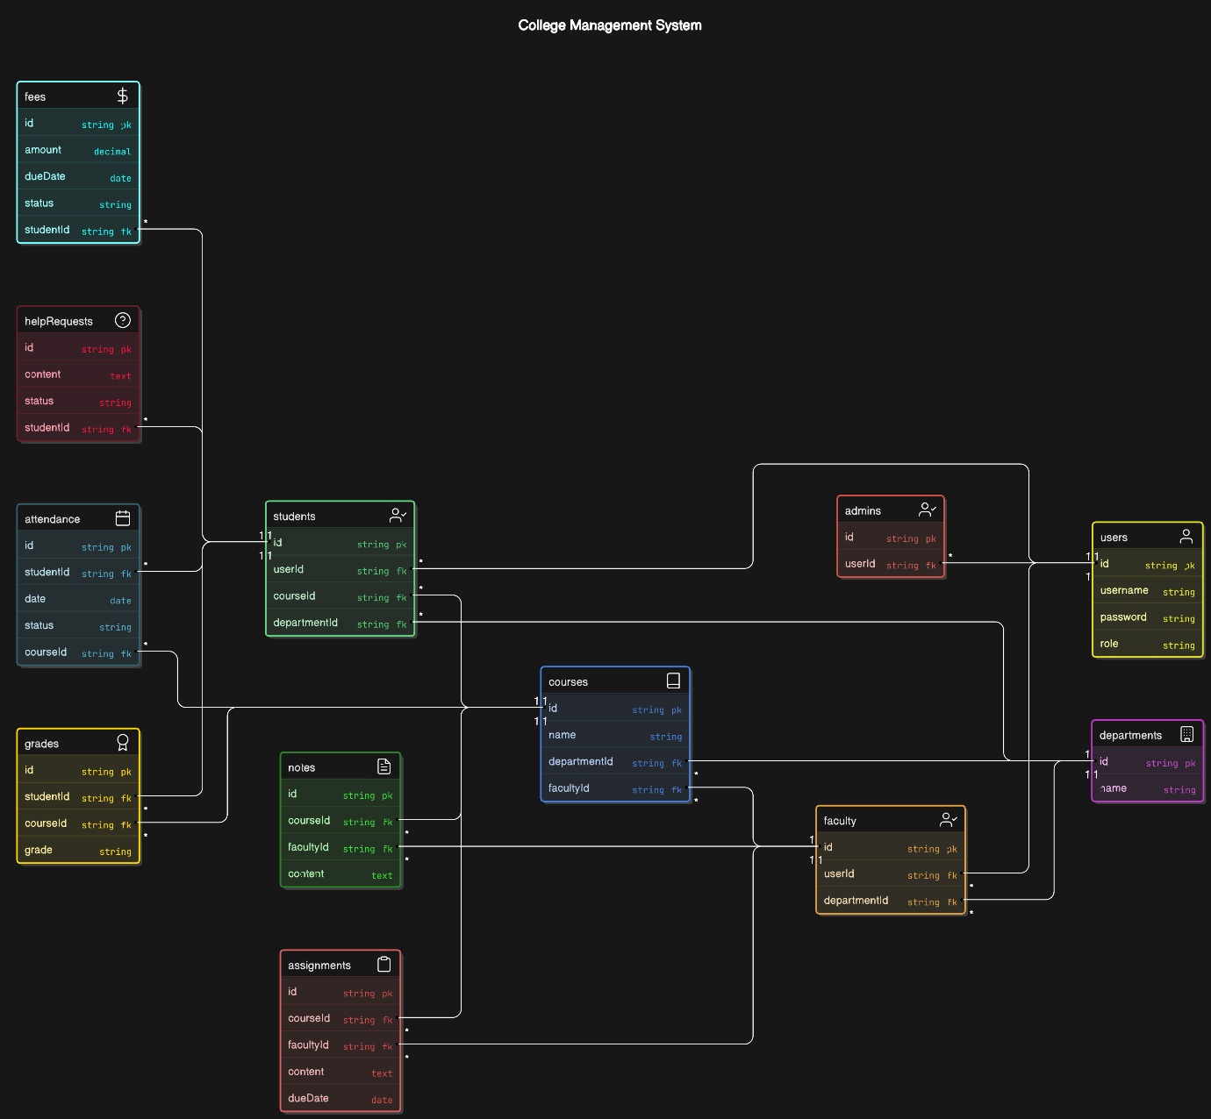

**Fig. 4.1.1: Class Diagram**

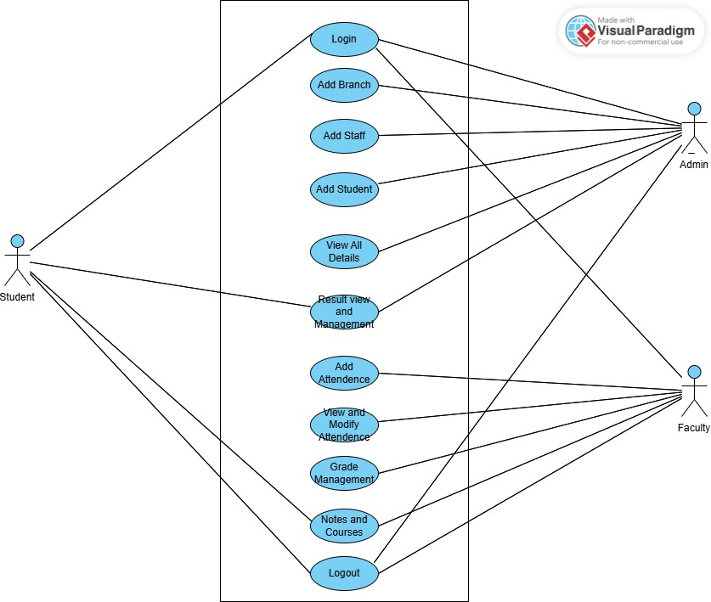

**Fig. 4.1.2: Use Case Diagram**

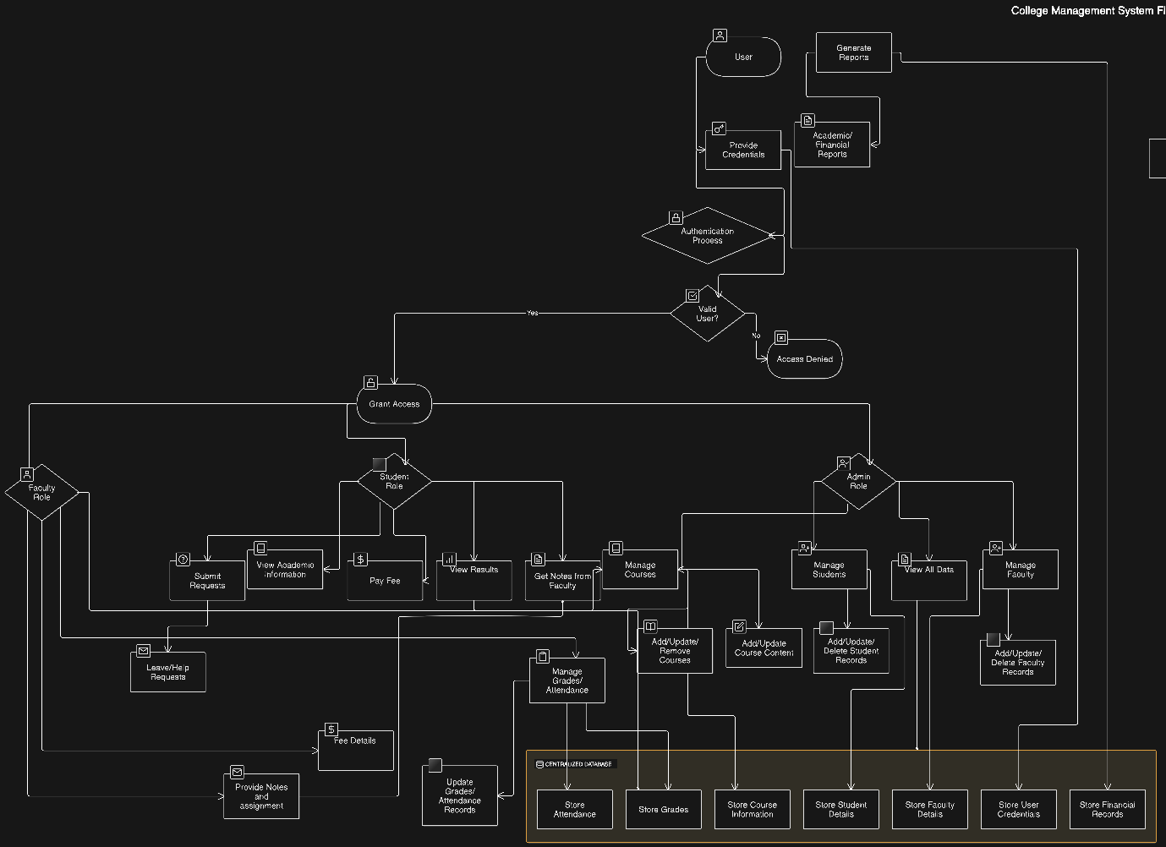

**Fig. 4.1.3: FlowChart**

* **Snapshots: Visuals of UI and Database**

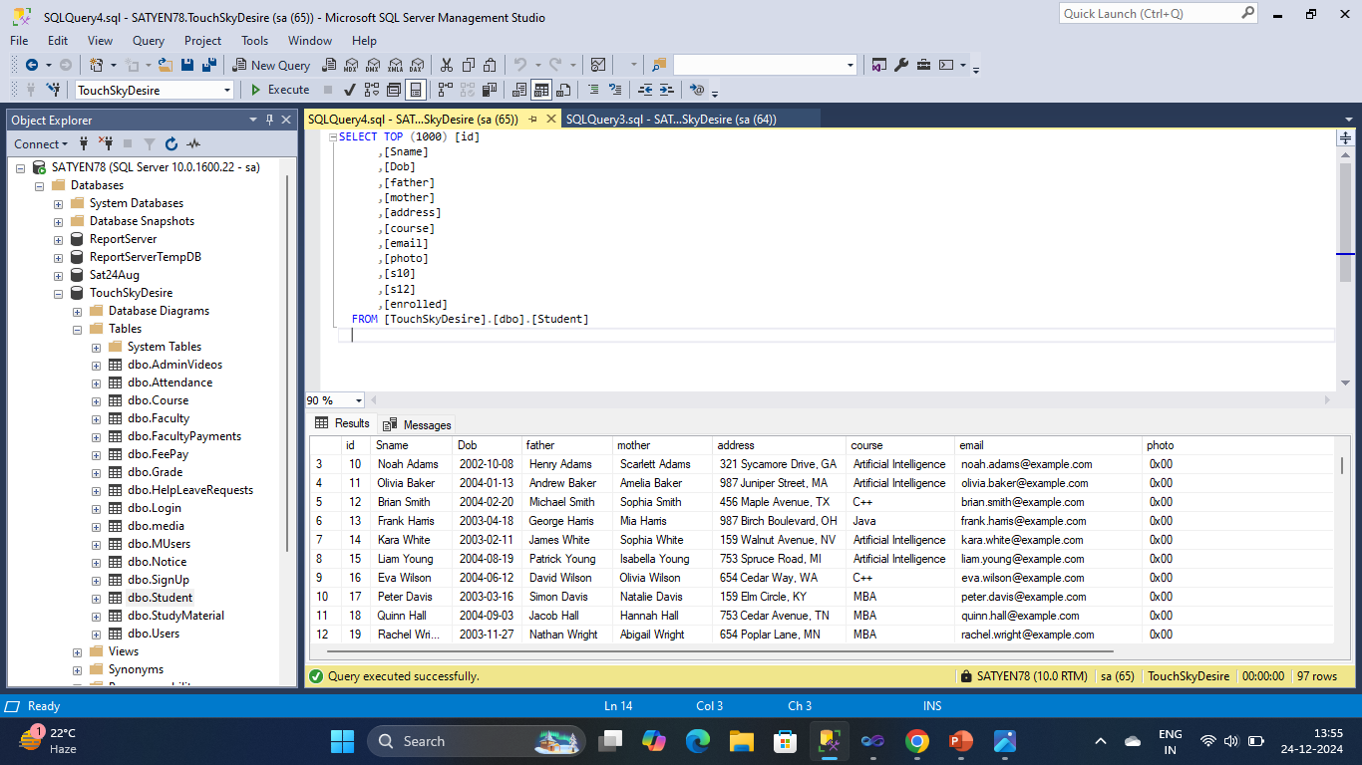

**DATABASE SQL TABLES**

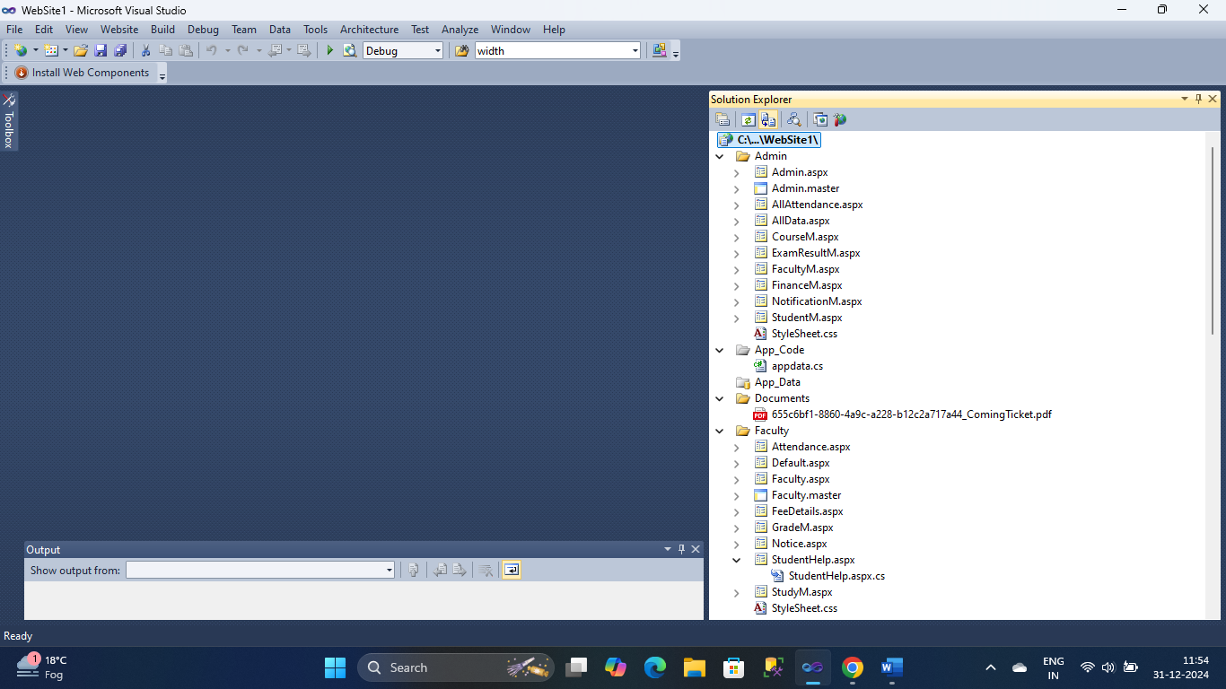

**ADMIN /APP_CODE / FACULTY PAGES**

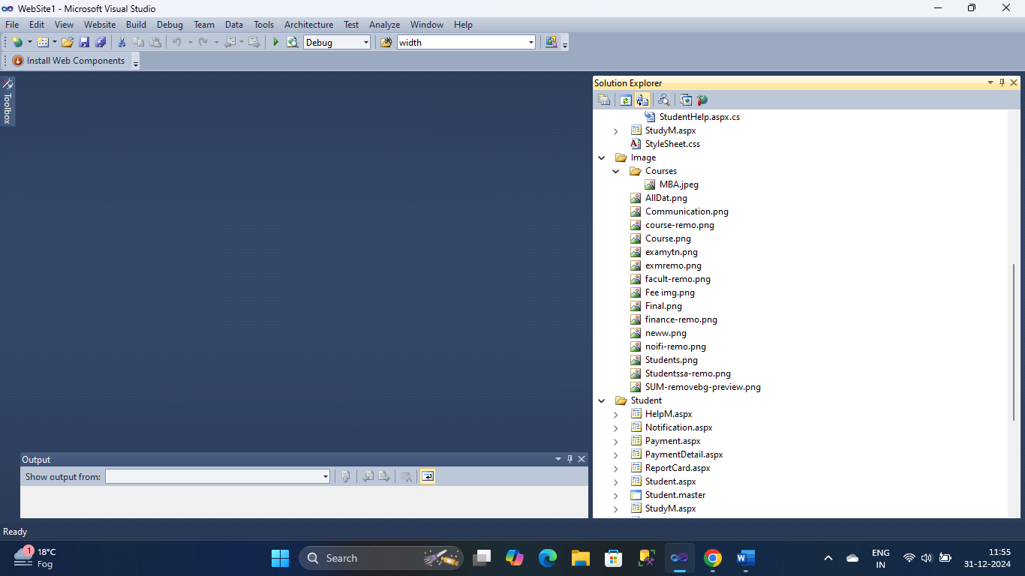

**MEDIA / STUDENT PAGES**

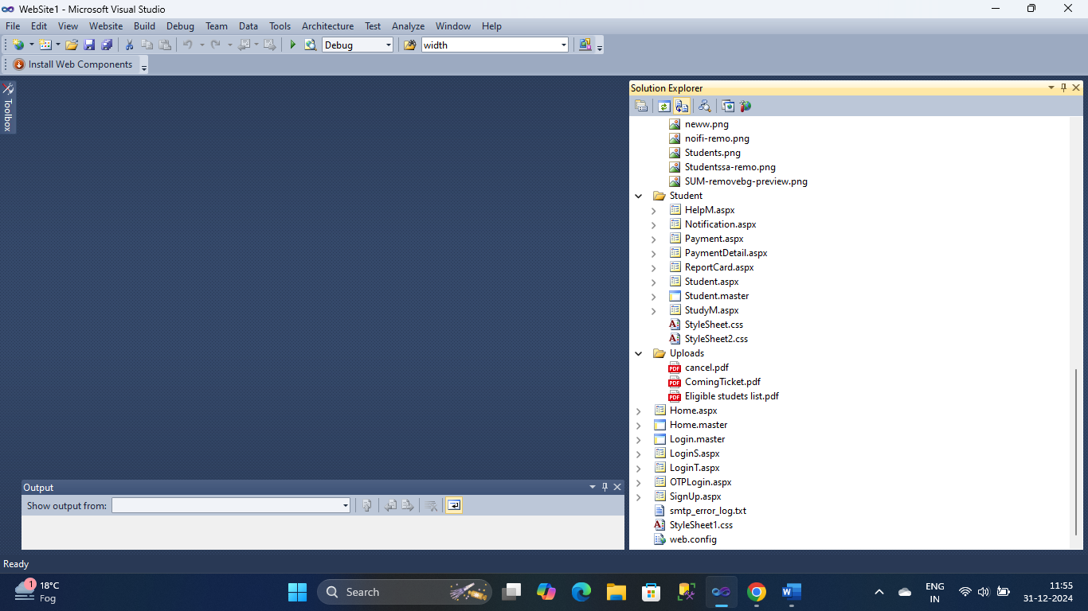

**STUDENT / HOME PAGES**

**4.1.2 Dataset Considerations:**

* **Data Volume**: Estimating the expected volume of data that the system will need to handle.
* **Data Types**: Identifying the different types of data that will be stored in the system, such as student demographics, academic records, financial transactions, and system logs.
* **Data Sources:** Identifying the sources of data, such as student applications, academic transcripts, and financial records.
* **Data Quality**: Ensuring data accuracy, consistency, and completeness through data validation and cleansing mechanisms.

**4.1.3 Data import:**

* **Data Mapping:** Define clear mappings between existing data sources (e.g., spreadsheets, legacy systems) and the SUM database schema.
* **Data Validation**: Implement robust data validation mechanisms to ensure data accuracy and consistency during the import process. This may involve checks for data type, format, and range constraints.
* **Data Transformation:** Perform necessary data transformations (e.g., data cleansing, formatting, and conversion) to ensure data compatibility with the SUM database.
* **Data Loading:** Develop efficient data loading mechanisms to minimize downtime and ensure minimal disruption to ongoing operations. Consider techniques like batch loading or incremental loading.
* **Data Migration Testing**: Thoroughly test the data import process to identify and resolve any issues before going live.

**4.1.4 Preprocessing Dataset**

* **Data Cleaning:** This involves identifying and handling missing values, outliers, and errors in the dataset. Missing values may be imputed using techniques such as mean, median, or mode imputation, while outliers may be treated or removed based on domain knowledge or statistical methods.
* **Data Transformation:** Data transformation involves converting the format or structure of the dataset to make it suitable for analysis. This may include converting categorical variables into numerical representations (e.g., one-ho encoding), normalizing or standardizing numerical features, and scaling the data to a consistent range.
* **Feature Engineering:** Feature engineering involves creating new features or modifying existing ones to improve the predictive power of the dataset. This may include extracting date or time-related features from timestamp data, creating derived features based on domain knowledge, or encoding clinical features such as the day of the week or month of the year.
* **Data Integration:** If the dataset consists of multiple sources or data files, data integration may be necessary to combine and consolidate the data into a single cohesive dataset. This may involve merging datasets based on common identifiers or keys, resolving data conflicts, and handling duplicate records.
* **Data Reduction:** Data reduction techniques may be applied to reduce the dimensionality of the dataset and improve computational efficiency. This may include feature selection methods to identify the most relevant features for analysis, as well as dimensionality reduction techniques such as principal component analysis (PCA) or t-distributed stochastic neighbor embedding (t-SNE).
* **Data Sampling:** In some cases, the dataset may be too large to analyze in its entirety, necessitating data sampling techniques to select a representative subset of the data for analysis. This may include random sampling, stratified sampling, or oversampling/undersampling techniques to address class imbalance issues.
* **Data Splitting:** Before analysis, the dataset is typically split into training and testing sets to evaluate the performance of machine learning models. This ensures that the model's performance can be evaluated on unseen data and helps prevent overfitting.

**4.1.5 Data Manipulation**

* **Data Extraction:** Data Extraction involves retrieving relevant data from the dataset or external sources for analysis .This may include selecting specific columns or fields from the dataset, filtering rows based on criteria such as date range or product category, and retrieving additional data from external sources using APls or web scraping.
* **Data Transformation:** Data transformation encompasses modifying the structure or format of the dataset to make it suitable for analysis. This may include converting data types, standardizing units of measurement, and formatting dates and times. Additionally, data transformation may involve aggregating data at different levels of granularity (e.g., daily, weekly, monthly) to analyze trends over time.
* **Data Cleaning:** Data cleaning involves identifying and handling missing values, outliers, and errors in the dataset. Missing values may be imputed using statistical methods such as mean, median or mode imputation, while outliers may be treated or removed based on domain knowledge or statistical techniques. Additionally, data cleaning may involve correcting errors in data entry or formatting inconsistencies.
* **Data Aggregation:** Data aggregation involves combining multiple data points or records into summary statistics or aggregated measures. This may include calculating totals, averages, counts, or percentages for specific categories or groups within the dataset. Aggregated data can provide insights into overall sales performance, product popularity, and regional trends.
* **Data Enrichment:** Data enrichment involves enhancing the dataset with additional information or context to improve analysis. This may include merging datasets from different sources to incorporate external data such as demographic information, economic indicators, or competitor data. Additionally, data enrichment may involve deriving new features or variables from existing data to provide additional insights.
* **Data Filtering and Subset Selection:** Data filtering involves selecting subsets of the dataset based on specific criteria or conditions. This may include filtering data by date range, product category, geographic region, or customer segment to focus the analysis on relevant subsets of data. Additionally, data filtering may involve removing or excluding irrelevant or redundant data from the dataset.
* **Data Joins and Merging:** Data joins and merging involve combining multiple datasets based on common keys or identifiers. This may include performing inner, outer, left, or right joins to merge datasets by matching key variables. Data joins enable analysts to combine information from different sources to perform comprehensive analysis and derive insights.

**4.1.6 Data Visualization:**

* **Exploratory Data Visualization:** Exploratory data visualization involves creating visual representations of the sales dataset to explore its structure, patterns, and relationships. Techniques such as scatter plots, histograms, and box plots are used to visualize distributions, correlations, and outliers in the data. Exploratory visualization helps analysts gain initial insights into the data and identify areas for further analysis.
* **Trend Analysis:** Data visualization is used to analyze trends and patterns in Diwali sales data over time, Line charts, time series plots, and area charts are commonly used to visualize sales trends, seasonal patterns, and fluctuations in demand during the Diwali period. Trend analysis helps identify recurring patterns and seasonality in sales data, enabling better forecasting and resource allocation.
* **Geospatial Analysis:** Geospatial analysis involves visualizing sales data on maps to analyze regional variations and geographical trends. Choropleth maps, heatmaps, and bubble maps are used to Visualize sales by location, identify high-performing regions, and assess market penetration. Geospatial analysis helps identify opportunities for expansion, target marketing efforts, and optimize distribution channels.
* **Product Performance:** Data visualization is used to analyze the performance of individual products or product categories during the Diwali sales season. Bar charts, pie charts, and stacked bar charts are used to visualize sales by product, identify best-selling products, and assess product performance over time. Product performance analysis helps inform inventory management, pricing strategies, and product promotions.
* **Customer Segmentation:** Data visualization is used to segment customers based on their purchasing behavior, demographics, and preferences. Scatter plots, cluster analysis, and heatmaps are used to visualize customer segments, identify buying patterns, and tailor marketing strategies to specific customer groups. Customer segmentation analysis helps personalize marketing efforts, improve customer targeting, and enhance customer satisfaction.
* **Dashboard Creation:** Dashboards are used to consolidate and visualize key performance indicators (KPIs) and metrics related to Diwali sales analysis, Interactive dashboards allow stakeholders to explore sales data, drill down into specific insights, and track performance metrics in real time. Dashboard provide a centralized view of sales performance, facilitate data driven decision making, and support strategic planning during the Diwali sales season

**4.2 Analysis:**

Analysis is a crucial phase in the development of Scholar Ultimate Matrix (SUM), an Institutional Management System. It involves a thorough examination of the system's requirements, design, and functionality to ensure it meets the desired objectives and provides optimal performance. This analysis encompasses various aspects:

**4.2.1. Functional Analysis:**

* **Feature Breakdown:**
  + **Student Section:** Analyzing the usability and effectiveness of features like online course registration, grade viewing, attendance tracking, result access, fee payment, library access, and communication features.
  + **Staff Section:** Analyzing the ease of use and efficiency of features like grade entry, attendance management, leave management, and communication features.
  + **Admin Section:** Analyzing the effectiveness of features like user management, course management, branch management, fee management, report generation, and the notification system.
  + **Common Features:** Analyzing the security and usability of login/signup, OTP login, and the overall system accessibility.
* **Workflow Analysis:** Examining the flow of information and processes within the system, identifying potential bottlenecks and areas for improvement.
* **Use Case Analysis:** Developing use case diagrams to visualize user interactions with the system and identify potential scenarios.

**4.2.2. Data Analysis:**

* **Data Flow Analysis:** Tracing the movement of data within the system, from input to output, to identify potential data integrity issues.
* **Data Validation:** Analyzing data entry fields to ensure data accuracy and consistency.
* **Data Security Analysis:** Evaluating data encryption, access controls, and other security measures to protect sensitive information.
* **Data Storage and Retrieval:** Analyzing the efficiency and scalability of data storage and retrieval mechanisms.

**4.2.3. Performance Analysis:**

* **System Load Testing:** Simulating real-world usage scenarios to assess system performance under varying loads.
* **Response Time Analysis:** Measuring the time taken by the system to respond to user requests.
* **Resource Utilization Analysis:** Monitoring CPU usage, memory consumption, and other system resources to identify performance bottlenecks.

**4.2.4. Usability Analysis:**

* **User Interface (UI) Analysis:** Evaluating the aesthetics, clarity, and ease of use of the user interface.
* **User Experience (UX) Analysis:** Analyzing the overall user experience, including ease of navigation, intuitiveness, and satisfaction.
* **Usability Testing:** Conducting user testing sessions to gather feedback on the system's usability and identify areas for improvement.

**4.2.5. Security Analysis:**

* **Vulnerability Assessment:** Identifying and assessing potential security vulnerabilities, such as hacking, data breaches, and denial-of-service attacks.
* **Penetration Testing:** Simulating real-world attacks to evaluate the system's security defenses.
* **Security Audits:** Conducting regular security audits to identify and address any security issues. 1

**5.IMPLEMENTATION**

Analysis is a crucial phase in the development of Scholar Ultimate Matrix (SUM), an Institutional Management System. It involves a thorough examination of the system's requirements, design, and functionality to ensure it meets the desired objectives and provides optimal performance. This analysis encompasses various aspects:

**1. Functional Analysis:**

* **Feature Breakdown:** 
  + **Student Section**: Analyzing the usability and effectiveness of features like online course registration, grade viewing, attendance tracking, result access, fee payment, library access, and communication features**.**
  + **Staff Section:** Analyzing the ease of use and efficiency of features like grade entry, attendance management, leave management, and communication features.
  + **Admin Section:** Analyzing the effectiveness of features like user management, course management, branch management, fee management, report generation, and the notification system.
  + **Common Features:** Analyzing the security and usability of login/signup, OTP login, and the overall system accessibility.
* **Workflow Analysis:** Examining the flow of information and processes within the system, identifying potential bottlenecks and areas for improvement.
* **Use Case Analysis:** Developing use case diagrams to visualize user interactions with the system and identify potential scenarios.

**2. Data Analysis:**

* **Data Flow Analysis**: Tracing the movement of data within the system, from input to output, to identify potential data integrity issues.
* **Data Validation:** Analyzing data entry fields to ensure data accuracy and consistency.
* **Data Security Analysis:** Evaluating data encryption, access controls, and other security measures to protect sensitive information.
* **Data Storage and Retrieval:** Analyzing the efficiency and scalability of data storage and retrieval mechanisms.

**3. Performance Analysis:**

* **System Load Testing:** Simulating real-world usage scenarios to assess system performance under varying loads.
* **Response Time Analysis:** Measuring the time taken by the system to respond to user requests.
* **Resource Utilization Analysis**: Monitoring CPU usage, memory consumption, and other system resources to identify performance bottlenecks.

**4. Usability Analysis:**

* **User Interface (UI) Analysis:** Evaluating the aesthetics, clarity, and ease of use of the user interface.
* **User Experience (UX) Analysis:** Analyzing the overall user experience, including ease of navigation, intuitiveness, and satisfaction.
* **Usability Testing:** Conducting user testing sessions to gather feedback on the system's usability and identify areas for improvement.

**5. Security Analysis:**

* **Vulnerability Assessment:** Identifying and assessing potential security vulnerabilities, such as hacking, data breaches, and denial-of-service attacks.
* **Penetration Testing:** Simulating real-world attacks to evaluate the system's security defenses.
* **Security Audits:** Conducting regular security audits to identify and address any security issues. 1

**5.1 Software Tools**

In the context of software development, the combination of ASP.NET, C#, SQL Server, and SMTP provides a robust set of tools for creating dynamic, data-driven web applications. Each of these technologies plays a specific role, allowing developers to build, manage, and maintain applications effectively. Let’s explore each of these technologies and their functions in detail.

**5.1.1 ASP.NET: For Dynamic Web Development**

**Purpose:**

ASP.NET is an open-source, server-side web framework developed by Microsoft. It is used for building modern web applications, including dynamic websites, APIs, and web services. ASP.NET allows developers to create web applications that can interact with databases, provide user authentication, and manage dynamic content, among other features.

**5.1.2 C#: Backend Logic**

**Purpose:**

C# (pronounced "C-sharp") is a modern, object-oriented programming language developed by Microsoft. It is primarily used for backend development in ASP.NET applications, where it handles the business logic, data processing, and server-side functionality.

**5.1.3 SQL Server: Database Management**

**Purpose:**

SQL Server is a relational database management system (RDBMS) developed by Microsoft. It is used to store and manage the data used by web applications, such as user accounts, product information, transactions, and other business data.

**5.1.4** **SMTP: Email Notifications**

**Purpose:**

SMTP (Simple Mail Transfer Protocol) is a protocol used for sending emails. It is used in web applications to send email notifications to users, such as account creation confirmation emails, password reset emails, or order confirmation emails.

**5.2 Coding Standard**

Coding standards are a set of guidelines or best practices that developers follow when writing code to ensure consistency, maintainability, and readability. These standards help teams work together effectively, improve collaboration, and produce code that is easy to understand and debug. Three core aspects of coding standards are modular programming principles, consistent naming conventions, and thorough documentation. Below is a detailed explanation of these key principles:

**5.2.1 Adherence to Modular Programming Principles**

Modular programming is a design technique that involves breaking down a program into smaller, self-contained units (modules) that are easier to manage, maintain, and test. Each module focuses on a single responsibility or task and can be developed and tested independently.

**Key Practices for Modular Programming:**

Single Responsibility Principle (SRP): Each module (or function) should perform only one task, making the code more focused and simpler to modify.

Clear Interfaces: Modules should communicate with each other through well-defined interfaces, allowing them to be connected without unnecessary dependencies.

Encapsulation: Hide the internal details of each module, exposing only what is necessary to interact with other modules

**5.2.2 Consistent Naming Conventions**

Naming conventions refer to a standardized way of naming variables, functions, classes, and other entities in code. Consistent naming helps ensure that code is readable, understandable, and predictable. It allows developers to quickly identify the purpose of a variable or function just by reading its name.

**Key Benefits of Consistent Naming:**

Clarity: Clear and consistent names make the code easier to understand, reducing the cognitive load on developers.

Reduced Errors: Following conventions helps avoid mistakes, such as misnaming variables or functions, which can lead to bugBetter Collaboration: When everyone follows the same naming conventions, it's easier for teams to collaborate and contribute to the codebase without confusion.

**6. TESTING**

Testing is a critical aspect of software development that ensures the quality, reliability, and performance of the system. Comprehensive testing involves different levels of testing, each focusing on a specific part of the system to identify issues early, verify that components work as expected, and ensure that the system meets user requirements. The key types of testing are Unit Testing, Integration Testing, System Testing, and Performance Testing.

**6.1 Unit Testing: Individual Modules**

Unit Testing focuses on testing the smallest units of code, usually individual functions or methods, to ensure that each part of the program behaves as expected. Unit tests are typically written by developers as they build the software, helping catch issues early in the development process.

**Key Aspects of Unit Testing:**

**Isolation:** Unit tests target individual components of the system, such as functions, methods, or classes, and verify that they work independently. Each unit is tested in isolation from the rest of the system to ensure that it functions correctly.

**Automation:** Unit tests are typically automated, meaning they can be run quickly and frequently during development to catch bugs early.

**Test Cases:** Unit tests consist of multiple test cases that cover different scenarios, including edge cases (unusual or extreme inputs) and expected outcomes. For example, testing a function that calculates the sum of two numbers should include tests for positive numbers, negative numbers, and edge cases like zero or very large numbers.

**Benefits of Unit Testing:**

**Early Bug Detection**: Since unit tests focus on small parts of the code, bugs can be detected early in development, reducing the cost and time required for debugging later.

**Refactoring Confidence:** When refactoring or updating code, unit tests ensure that existing functionality is not broken.

**6.2 Integration Testing**

Integration Testing verifies that different modules or components of the system work together as expected. Unlike unit testing, which tests individual units in isolation, integration testing focuses on how well multiple components interact when integrated into a larger system.

**Key Aspects of Integration Testing:**

**Combining Units:** In integration testing, individual units that have passed their unit tests are combined, and the interactions between them are tested. This ensures that the components, when put together, function properly and communicate as intended.

**Interface Testing:** It focuses on testing the interfaces between modules. For example, if one module returns data to another module, integration tests verify that the data is received and processed correctly.

**Data Flow:** Integration tests ensure that the data flows correctly between modules, and that shared resources, such as databases or APIs, are accessed and used properly.

**Benefits of Integration Testing:**

**Detecting Interface Issues**: Integration testing helps uncover issues related to how modules interact, such as incorrect data being passed between modules or conflicts arising from integration.

**System Behavior Validation:** It ensures that the system behaves as expected when the modules are combined, which helps verify the overall logic of the application.

**Realistic Scenarios:** Integration tests often simulate real-world usage by testing how various parts of the system interact in a controlled manner.

**6.3 System Testing**

System Testing is the process of testing the entire system as a whole to verify that it meets the specified requirements and works as expected in a real-world environment. This type of testing includes functional and non-functional aspects, ensuring that the system performs all the required tasks.

**Key Aspects of System Testing:**

**End-to-End Testing:** System testing involves running the complete system, often in an environment that mirrors the production setup, to ensure that all components work together as expected.

**Test All Features**: All functionalities, including user interactions, external integrations, security measures, and more, are tested to ensure that the system meets the functional requirements.

**Acceptance Criteria:** It validates whether the system meets the specified requirements from the perspective of end users. This includes testing user interfaces, workflows, and use cases to confirm that the system works from start to finish.

**Non-Functional Testing:** In addition to functional requirements, system testing may also cover performance, security, and usability testing.

**Benefits of System Testing:**

**Holistic Validation:** System testing ensures that the entire application behaves correctly and meets user expectations, rather than just individual modules.

**User-Centric Testing**: Since it tests the system as a whole, system testing closely resembles how users will interact with the software, providing insights into user experience and workflow.

**Regulatory Compliance:** For certain industries (e.g., healthcare, finance), system testing helps ensure that the software complies with regulations and standards.

**6.4 Performance Testing**

Performance Testing is the process of evaluating the speed, responsiveness, and scalability of the system under varying loads. It ensures that the system performs well even under stress, and can handle increased traffic or usage without degrading performance.

**6.5 Results and Discussion**

In the Results and Discussion section, the goal is to present the outcomes of the software testing, development process, and performance assessments. It provides insights into how the system has been evaluated, any challenges faced, and how well it meets the design requirements. This section is key to demonstrating that the system works as intended and discussing its capabilities in real-world scenarios.

**6.6 Final Look of the UI and Database**

Snapshots refer to screenshots or visual representations of the key components of the system. These visuals help provide an understanding of how the system looks and operates. In the context of an educational management system (SUM), the following types of snapshots are typically included:

User Interface (UI) Snapshots: These images capture the graphical interface that users interact with. This can include:

**Login Screens:** How users log in to the platform, including username/password fields and the user experience.

**Dashboard:** A view of the main dashboard where users (administrators, teachers, students) can access different features of the system.

Forms: Screens showing how users enter and manage data, such as student registration forms, course management, or attendance tracking forms.

**Reports**: Visuals of reports like student grades, attendance records, and performance analytics.

Admin and Teacher Views: These snapshots could show the administrative interface and tools used by staff to manage student records, grades, schedules, and more.

**Database Snapshots:** These represent how data is structured and managed within the database. Screenshots of database management tools (such as SQL queries or database tables) could be used to display:

**Student and Teacher Data**: The tables that store details like student names, IDs, grades, courses, etc.

Course and Enrollment Records: Snapshots showing how courses are stored and linked to students.

**Data Queries:** Examples of queries used to retrieve or manipulate data within the system, such as extracting student performance data for reports.

These snapshots help stakeholders, developers, and users visualize the key components of the system and understand how the user interacts with the application, as well as how data is structured behind the scenes.

**System Performance: Metrics like Response Time and User Load Capacity**

System performance is a critical measure of how well the system operates under various conditions, particularly when it comes to response times and scalability. It helps determine if the system can handle real-world usage **effectively and** whether it can maintain its responsiveness under heavy load.

**Response Time:** This refers to how quickly the system responds to user request.

**example:**

The time it takes for a student to log in after entering credentials.

The time it takes to generate a report of student grades or attendance.

Load time for pages, especially on the dashboard, where users access multiple features.

Performance testing tools, such as JMeter, Gatling, or LoadRunner, can be used to measure response times across different user actions. The goal is to ensure that response times are quick and within acceptable limits, typically aiming for less than 2 seconds per action for a smooth user experience.

User Load Capacity: This metric assesses how many users the system can handle concurrently without performance degradation. During performance testing, the system is subjected to different levels of traffic or user load to observe its behavior:

Scalability Testing: This involves gradually increasing the number of simulated users (students, teachers, admins) accessing the system simultaneously. It determines the system's capacity to handle large numbers of users, which is essential for educational institutions with thousands of students and faculty members.

Stress Testing: This tests the system’s breaking point by pushing it to handle a larger number of users than it is designed for to understand how it behaves under extreme stress. If the system fails, this could reveal bottlenecks or parts of the system that need optimization.

These performance metrics help ensure that the system is robust enough to handle daily usage and can scale as the institution grow

1. **CONCLUSION**

The Conclusion section summarizes the overall achievement of the project, aligning it with the objectives outlined in the beginning. It highlights how well the system meets the original goals and objectives.

**For example, in the case of a School/University Management System (SUM), the conclusion might focus on:**

**Centralized Platform:** The system effectively integrates various administrative and educational tasks into a single platform, making it easier for educators, students, and administrators to manage school activities and resources.

**Efficiency**: The system streamlines processes like student registration, grade management, and attendance tracking, reducing manual effort and improving overall operational efficiency.

**User-Friendliness:** The system is designed with an intuitive user interface that makes it accessible to users with varying levels of technical expertise, from students to administrators.

**Flexibility:** The system provides flexibility in managing courses, students, schedules, and other resources, allowing for customization based on the institution’s needs.

Overall, the conclusion should affirm that the SUM platform successfully delivers on its promise to centralize and simplify educational management tasks, offering a practical, efficient solution to educational institutions

1. **FUTURE ENHANCEMENTS**

The Future Enhancements section outlines potential improvements and features that could be added to the system in future iterations. These enhancements aim to increase the system's functionality, usability, and adaptability to meet evolving needs.

**1. Mobile Application Development**

While a web-based platform might work for most administrative functions, mobile access offers significant benefits, especially in an educational environment. A mobile app would allow students, teachers, and administrators to:

**Access Information Anytime, Anywhere:** Mobile apps would allow users to view grades, attendance, course materials, and schedules on-the-go.

**Push Notifications:** The app could send notifications for class schedules, exam dates, grade updates, and other important announcements, keeping users engaged and informed.

**Offline Functionality**: The app could allow users to access certain features offline and sync data once an internet connection is available, which would be helpful in areas with limited connectivity.

**2. AI-Based Analytics**

**Incorporating AI-based analytics into the system would enhance decision-making and improve the overall educational experience. With AI, the system could:**

**Predict Student Performance:** AI could analyze historical data to predict student performance and provide early alerts to students or teachers if performance declines. This could help identify at-risk students and provide targeted interventions.

**Personalized Learning:** Based on student data, AI could offer personalized learning paths, recommending courses or materials based on the student’s strengths and weaknesses.

**Administrative Insights:** AI could assist administrators by predicting trends, such as enrollment numbers, attendance patterns, and resource utilization, enabling more efficient resource allocation.

**3. Multi-Language Support**

Multi-language support would make the system more inclusive and accessible to a wider range of users. Educational institutions often have diverse student populations with different language preferences. By supporting multiple languages the system can:

Serve a Global Audience: Institutions with international students could provide a system that accommodates different languages, making it easier for students to use the platform in their preferred language.

Increase Adoption: Multi-language support could improve user adoption rates by offering localized versions of the platform, ensuring that users from different linguistic backgrounds can interact with the system comfortably.

Multi-language support would also be an important consideration for institutions operating in regions where multiple languages are spoken, enabling a more inclusive environment for all users.

**REFERENCES**

openai/chatgpt.com

scribd.com

copilot.com

geeksforgeeks.com

gemini.net

wikipedia.com